CLOSING DATE FOR APPLICATION: Monday 15th July 2024
INTERVIEWS: W/B 15th July 2024


JOB TITLE: TEACHING ASSISTANT LEVEL 2
Teaching Assistant (Level 2) Grade D NJC 5-6
£23,500 - £23,893 FTE,
(£16,994.53 to £17,278.74 Actual Salary )
Fixed Term Contract Linked to High Needs Funding
This prospective applicant pack provides you with all the relevant information you need to apply for the vacancy being advertised. The pack also provides a lens into our school community
through content that we have created for you.

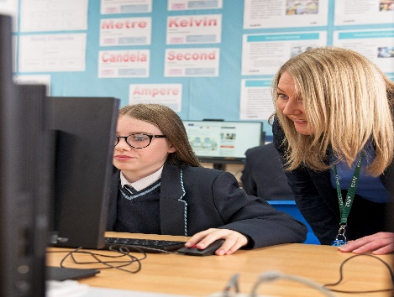

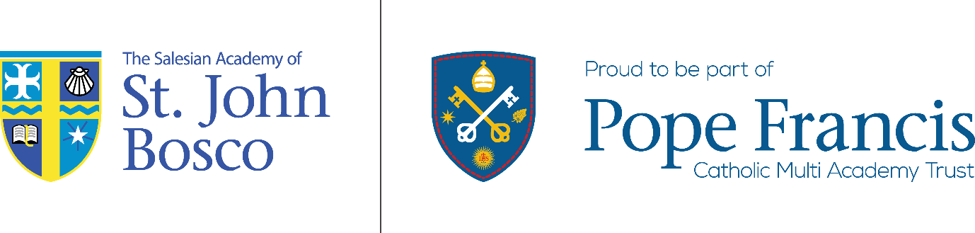

Welcome from the Headteacher

Dear candidate

As Headteacher of The Salesian Academy of St John Bosco I am delighted with your interest in joining our team.

The newly appointed Teaching Assistant will play a vital role in delivering our vision of securing the very best standards of teaching and learning so that pupils, regardless of their background, abilities or specific learning needs, remain healthy, successfully complete their formal education, and are able to make positive contributions towards society. In this post you will be working alongside the SENDco, your role will be to create and maintain high standards and aspirations underpinned by our Salesian and Gospel values and to secure outstanding outcomes.

There is a new ambition for The Salesian Academy of St John Bosco, driven by the strong partnership that exists between Pope Francis Catholic Multi Academy Trust and the Salesians. This ambition, alongside the build of a new school in 2026, will provide an exciting environment for pupils and staff alike to develop their many talents and pursue academic and personal excellence.

If you are confident that you have the qualities, skills and ambition we are looking for, as well as the enthusiasm, knowledge and resilience to shape the future of our school, I look forward to receiving your application.

Sue Bourgade
Headteacher

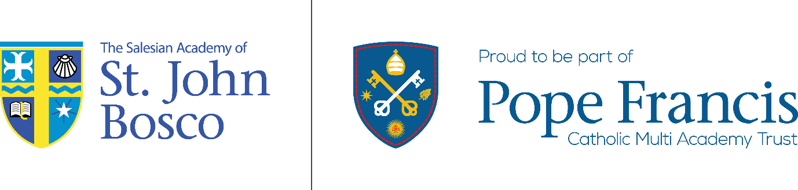

Welcome from the CEO

Dear Candidate

Thank you for your interest in our school and our Catholic MAT; both the Pope Francis Catholic Multi Academy Trust and The Salesian Academy of St John Bosco are at an exciting point in their development.

The Pope Francis Catholic MAT is the first of the Catholic Multi Academy Trusts that are being formed by the Archdiocese of Liverpool. Each school within the Archdiocese will be given the opportunity to join one of 12 locally based Catholic MATs. We are the first of these MATs and are therefore acting as a pathfinder for the MATs that will follow. At present there are three schools within the CMAT; Saint Edmund Arrowsmith Catholic Academy in Whiston, Sacred Heart Catholic Academy in Crosby and The Salesian Academy of St John Bosco in Bootle. The Pope Francis Catholic MAT will serve the Sefton area and may ultimately include up to 29 Catholic schools, both primary and secondary.

The Archdiocesan Catholic MATs will work closely with one another and have a clearly defined philosophy about the way in which a Multi Academy Trust works. We believe that each of our schools has their own distinct identity, history, tradition and values. We believe very much in the preservation of this identity and that the role of the Trust is to work with the Headteacher to offer support and the highest quality services to enable the schools to focus exclusively on providing the highest quality of education rather than dealing with other distractions. We aim to create a collaborative Trust where all individuals are able to thrive and flourish knowing that they are being underpinned by the highest quality support.

Our Mission is clearly laid out, “Enabling schools, aspiration and faith to flourish by uplifting hearts and inspiring minds.”

Our Values are:

· Unity – working together for excellence

· Excellence – to strive to be the best

· Love – respect and care for others and treat them as you want to be treated

· Service – following the teachings of Christ to become valued members of our communities
The Salesian Academy of St John Bosco became part of the Trust on 1st January 2023. The school was formerly known as Savio Salesian College. In the last six years the school has faced a difficult journey. In recent years, it has been inspected three times and each time the Overall Effectiveness has been judged to be Inadequate, the latest being in September 2022. This only tells part of the school’s story and there is a well-grounded and strong sense of optimism within the school.

The Salesian ethos pervades all aspects of school life and pupils value the way in which they are loved and cared for. Mrs Sue Bourgade was appointed as Headteacher in April 2023 to build on this and have the highest expectations. The school has strong support from the DfE and was included as part of the schools rebuilding programme and we expect the new school to be ready for the pupils to move into in 2026.

Andrew Dawson

CEO Pope Francis CMAT

JOB TITLE: TEACHING ASSISTANT LEVEL 2

Required for September 2024:

The Salesian Academy of St John Bosco is a rapidly improving school and we seek applications from highly motivated and inspirational people who are committed to ensuring every child and adult within our community has the self-belief to flourish in whatever they choose to do.

“In order to empower everyone to achieve their full potential we, as a community, accept our responsibility to respect and care for each other and our environment in a spirit of friendship and peace.”

The values that are reinforced daily are: Respect, Understanding, Affection, Happiness and Humour.

At The Salesian Academy of St John Bosco we believe that clear expectations regarding responsibilities and behaviour are important in maintaining a successful and happy atmosphere in school.

The Governors are determined to appoint an excellent Teaching Assistant to support improving SEND provision within the academy.

If you are someone that thrives on working in a dynamic environment with like-minded colleagues, then we would encourage you to make an application. This position is a unique opportunity for an exceptional person to support the school at this point of its development. It is an exciting opportunity to support school improvement and be instrumental in delivering high quality education in our community.

If you require any additional information or would like to visit the school, please email Mrs B Deegan, b.deegan@sjb.pfcmat.org who will help you with your request.

Full details of this post including the CES Support Staff Application form and associated documents are available to download from the school’s website: https://www.thesalesiansacademyofstjohnbosco.org/

The closing date for this application is Friday 12th July 2024, however we reserve the right to bring forward the deadline and appoint prior to this.

APPLICATION PROCESS

To apply for this post your completed application must be submitted to include the following documents:

  - CES Support Staff Application Form
  - CES Consent to Obtain References
  - CES Monitoring Form
  - Rehabilitation of Offenders Act 1974 Disclosure Form

Completed applications should be clearly marked with the post title and returned electronically for the attention of Mrs B Deegan, b.deegan@sjb.pfcmat.org

Full details of this post including the CES Support Staff Application form and associated
documents are available to download from the school’s website:
https://www.thesalesiansacademyofstjohnbosco.org/

The Salesian Academy of St John Bosco is committed to safeguarding the welfare of children. Disclosure of any criminal convictions and an enhanced DBS check will be required for this post. It is an offence to apply for the role if you are barred from engaging in regulated activity relevant to children. The post may not be exempt from the Rehabilitation of Offenders Act 1974 as certain spent convictions and cautions are ‘protected’ and are not subject to disclosure. It is important that an applicant provides the school with upfront disclosure of all unspent convictions, cautions, reprimands or warnings. A failure to declare the above (that are not subject to the Disclosure and Barring Service filtering) may disqualify an applicant for appointment and may result in summary dismissal if the discrepancy comes to light subsequently.

The recruitment process for this post will be underpinned by rigorous safer recruitment assessment to ensure that children and young people are protected.

An online social media search will be conducted of all applicants in line with Keeping Children Safe in Education Guidance.

We are an Equal Opportunities Employer.

JOB DESCRIPTION

Every member of staff at the Salesian Academy of St John Bosco is expected to endeavour to maintain and develop the Catholic and Salesian character of the school, and to support and promote the aims and mission of the school in and through the exercise of all contractual duties and any voluntary activities.

Post Title | Teaching Assistant Level 2
Salary Scale | Teaching Assistant (Level 2) Grade D NJC 5-6  £23,500 - £23,893 FTE,  (£16,994.53 to £17,278.74 Actual Salary )
Reporting to | Assistant Headteacher SEND & Inclusion
Responsible for | Supporting managing the provision of pupils identified as having Special Educational needs and Disabilities.
Pay and Conditions  Contract Type | Term Time only plus 5 INSET days  30 hours per week  Fixed Term (Linked to Higher Needs funding)
JOB PURPOSE
To support the day-to-day operation of the SEN policy, to work with and supervise individuals and groups of children under the direction/instruction of teaching and/or senior staff, inclusive of specific individual learning needs, enabling access to learning for all pupils and assistance and support in classroom management and behaviour techniques.

MAIN DUTIES

Support for the Pupils

- Establish good working relationships with pupils, acting as a role model
- Be aware of and respond appropriately to individual pupil needs ensuring effective interaction
- Provide specific support to pupil's dependent upon their individual needs ensuring their safety whilst supporting access to learning activities
- Support the SENDco to update and share Pupil Passports with relevant staff to communicate pupil need
- Promote inclusion and acceptance of all pupils
- Encourage pupils to interact with others and engage in activities led by the teacher
- Promote self-esteem and independence
- Provide feedback to pupils in relation to progress and achievement under the guidance and direction of the teacher
- Provide minimal clerical/administration support
- Assist with the display of children’s work
- Create and maintain a purposeful, orderly and supportive environment
- In liaison with the teacher, utilise strategies to support pupils in achieving learning goals
- Report pupil achievements, progress and issues as appropriate in agreed format
- Undertake pupil record keeping as requested
- Administer tests and invigilate exams as requested
- Promote good pupil behaviour, dealing promptly with conflict and incidents and encouraging pupils to take responsibility for their own behaviour in line with established school policy
- Establish constructive relationships with parents/carers

Support for the Curriculum

- Undertake structured and agreed learning activities/learning programmes, taking into consideration pupil learning styles and specific needs
- Undertake literacy/numeracy interventions with targeted pupils
- Support the use of ICT in learning activities and develop pupils’ competence and independence in its use
- Prepare, maintain and use equipment/resources required to meet the lesson plans/relevant learning activity and assist pupils in their use
Support for the School
- Be aware of and comply with school policies and procedures relating to child protection, health, safety and security, confidentiality and data protection. Report all concerns to the appropriate person (as named in the policy concerned).
- Be aware of and support difference and ensure all pupils have equal access to opportunities to learn and develop.
- Contribute to the school ethos, aims and development/improvement plan.
- Appreciate and support the role of other professionals
- Attend relevant meetings as required
- Participate in training and other learning activities as required
- Assist with the supervision of pupils out of directed lesson time, including before and after school if appropriate and within working hours
- Administer first aid (if not first aid trained, training will be provided)
- Accompany teaching staff and pupils on visits, trips and out of school activities as required

The post holder may reasonably be expected to undertake other duties commensurate with the level of responsibility that may be allocated from time to time

PERSON SPECIFICATION

 | Essential or Desirable
Skills  - Ability to work effectively within a team environment, understanding classroom roles and responsibilities  - Ability to build and maintain effective working relationships with all pupils and colleagues  - Ability to promote a positive ethos and role model positive attributes  - Ability to work with children at all levels regardless of specific individual need and identify learning styles as appropriate  - Ability to adapt own approach in accordance with pupil needs  - Excellent personal numeracy and literacy skills | E  E  E  E  E  E
Knowledge and Understanding  - Understanding of national curriculum and other learning programmes (within specified age range/subject area) e.g. knowledge of core subject areas, etc.)  - Understanding of principles of child development, learning styles and independent learning  - Working knowledge of relevant policies/codes of practice/legislation  - Understanding of inclusion, especially within a school setting  - Experience of resources preparation to support learning programmes  - Effective use of ICT to support learning  - Understanding of other basic technology and management information systems | E  D  E  E  E  E  D
Qualifications and Training  - Minimum 2 years' experience of working with children in an educational setting (within specified age range/subject area)  - NVQ II or equivalent intention to working towards in teaching assistance within specified age range/subject area  - Requirement to complete DfES Teacher Assistant Induction Programme  - Willingness to participate in relevant training and development opportunities  - Training in the literacy/numeracy strategy  - Training in special educational needs strategies  - Willingness to undertake appointed person certificate in first aid administration | D  E  E  E  E  E  E
Professional Values and Practice must be able to demonstrate the following:  - High expectations of all pupils; respect for their social, cultural, linguistic, religious and ethnic backgrounds; and commitment to raising their educational achievements  - Ability to build and maintain successful relationships with pupils, treat them consistently, with respect and consideration, and demonstrate concern for their development as learners  - Demonstrate and promote the positive value, attitudes and behaviour they expect from the pupils with whom they work  - Ability to work collaboratively with colleagues, and carry out role effectively,  - Able to liaise sensitively and effectively with parents and carers, recognising role in pupils’ learning  - Able to improve their own practice through observations, evaluation and discussion with colleagues | E  E  E  E  E  E

